INTRODUCTION

Red rose (ra slamascene mill) of rosaceae family has secondary mitabilites, such as terpener, glycosides, flavonoidles andanthocyanins which isetant from flowers, petals and hips The phantacological function of micose e antioxidants, free rutical svengers, miticancer, antimutagenic, idepressant, and anti-inflammatory, Antributed to phenolics compounds

Red china rose Hilsiscus rosa-sinensial) of malescese family contain vitamina Davonoids ascorbic acid, nisein, riboflavin,thiamine, and cyanidindighcoside (anthocyanins) in Bowers its flows have phanaacological function, such as oral contraceptive, laxative. aphrodisia

The petals of red rose and red china rose are red because of anthocyanin, water-soluble plant pigments, which can be used as sutural dye and berbal medicines due to cocondary metabolites Anthrocyanins color stability depend on anthrocyaninstructure, pH, temperature, oxygen, light and water activity. The aim of this study was to compare the total anthocyanin content of petals of red rose and red china rose which extraciet with maceration and percolation method

The popularity of rose has lead to great efforts being made towards the development of varieties exhibiting diverse libits of growth and flowering and especially those producing large blooms with numerous petals and attractive colors bunders of named varieties have thus been t created and widely distributed. They are to be found listed and silustrated in several publication. The colors which are forthcoming are so striking and sas varied that considerable interest attaches to the problem of their origin

The fint step towards the elucidation of these colours is to classify them into distinct groups. We may begin with some familiar colors, viz, yellow orange, scarlet,red and crimson- limiting ourselves to those cases in which these colours exhibit the maximum degree of saturation or fullness. But not all roses can thus be described. Many present similarity in colour to spectral yellow, orange,or rod, but are of less saturated hues. Other colours, again, bear nog resemblance to any of the pure spectral colours, various special names have been given to rose colours, viz., cream, pink, salmon, vermilion,mauve and lilne. To this list must be added the multi-coloured roses which display different colours on the front and revicnic faces of the petals, artet and yellow, or ral and white, while others per different cutour the same side of the pal.

THE GENESIS OF THE COLOURS

We are chiefly juested herein shumica problem, in other words, with ascerting thenature of the pigments press in the petals which alerts the light rays incident one, the my which peach shoeperti and age as difused light determining the bed. Colour Obervation of the Dowers held in light dough a pocket spectroscope revis the role exhibiting vivid colours such as scarlet, sed or crimsen completely absorb angst of the visible spectrum, allowing only limited gions of it to capsed light. Salle observation with the les vividly coloured mam indicate only the parts of the spectrum which suffer the greatest memure of observation. Thus, in either case the information which is forthcoming does mitble any definite conclusion to be amivel at regarding the cbourpive properties, of the pigment over the entire range of the visibia spectrum these circumstances, it becomes nocmsary to rely on the study in vitro f the pigments extracted from the rose petals by wolves which do not fundamentally alter their optical behavion. The twe solvents which have her polyl in the authors arodies are ethyl alcohol acetone respectively. Rose petals immersed in ethyl alcohol are bleached and give sufficient time becomes practically colourless with yellow es, or with multi-coloured roses exhibiting yellow faces or sectors, the alcoholic schon exhibits a golden-yellow colour. On the other hand, the alenbelle extract of other roses is quite confess, from which we infer that the pigments responsible for the colour of mock roses has gone in to solution, but has simultaneously been transfansed into a colourless product. Rose petals immersed in acetone behave differently, Yellow roses, and the yellow areas in multi-coloured roses are not immediately affected. Yellow roses, and the other colours of the an be multi-coloured roses exhibiting colours other than yellow are quickly decolourised, and as and as the pigment is extracted from the petals, it dissolves in the acetonethan acquires its colour. The acetone extract may than be transferred in to an observation the with that enin Viewedagainst bright source of white light through a pocket spectroscope, the absorption spectrum of the solution it seen by the observer. The concentration of the acetone extract can be varind by sing fewer petals in the case may he red wjusting the quantity of the secon used for the extrin, It is also useful to have observation caffe greater or shorter lengths as may be und desirable, depending um the abength of the culoured extra Onervations made in this manner with optone extracts reveal that the extracted reveal that the entracted material is mach of the same are in at the cases which have bem studied by the author. Crimum roses, red res, Acarlet rise org ms and roses which ser light pink on deep pink, all present spectra which are very similar in appesence The ang wavelength mgion in the spectrum extending from 60thund 500 we strongly absorbst. Darker bands in which sach absorption in a maximum an clearly visible respectively in the green and yellow parts of the spectrum. There is aber an observable transmissooog light in the bun region of the spectrum. The alcoholic extract from yellow es examined spectroscopically exhibits an abortion which covers the short-way end of the spectrum and extends a litile beyond the blue open about 315.

**Explanation of the colour variations**

The features noticed in the recorded curve of absorption appearing as figured enable us to give a resonable explanation of the gruat rege of the colours actually exhibiting by roses The factor which is different for the roses of differnt colours is the quantity of pigmentary material present in the petals. On the basis of wach variation, it is possible to deduce the result to be espected and compare them with the actual facts of observation

We may begin with the cases in which the pigment is present in minimal quantities. It is evident from figuer I that in such cases, the end of wavelength from 500 to 550 and that it would be much less both at greater and similar wavelengths becomingaltogether insensible we approach the red end of the spectrum.Examination of pink rosus beld in bright light through a pocket spectroscopy discloses just such as situation. Further, it is found that the deeper the pink colour of the rose, the greater is the absorption noticeable in the green sector of the spectrum- between 500 to 550.But both the red and blue region of the spectrum persist.

We may next consider the cases in which the pigment is present in substantial quantities, sufficient to make the absorption by the petals completely effective except in the regions of the spectrum where the absorption power is quite small Referring again to it will be seen that in such can, me hight which exception could sppese inly at the extreme reil end of the spect that would be abgested fees When the quantity of pigmant available will smaller wavelength between 570 and 000 would conce the light shiffused by the pesh and the colour of the would at from rod in Suret With further disimation uf die quantity of pigment available, the light diffund by the pals would extend from susret s range Actually, when mange roses are viewed thong pocket spate, we and that the trim from the catromendu 150 g while shorter wavelengths are absorbed. In all these, the blogot the spectrum in marcely The auther ban not had opportunity of examining roses which have been described as exhibiting purplish. If blurones were ever forthcoming, they would assuredly exhibit in the red, yellow and green region. The spectrophotometer records reproduced shove vare made in the instruments laboratory of the indian institute of science, to the authornies of which the author thanks are slue Colour is vital constituents of the foods. Colour is the fint characteristics perceived by the senses and helps in determining acceptability, judging quality and increase husic pesthetic valon of food Increasing consumer averea for natural products with no chemical additives and certified dyes has necessitated the need to exploit food colourants of natural orgin. The prosent investigatio was carried out on "Methods of extraction of anthocyanins from red rose (Rose chinensisy Two solvent aqueous of ethanol-0.1% Hol, with the extraction temperature and stirring times were selected. Extraction temperatures a boiling point and with 10,15,and 20 minutes surring times were selected. Total anthocyanins content colour intensity, red units, yellow units and chroma value were respectively 308.77mg 100gmm, 12.35,8.55.38.15 und 39 10 for alcohol extraction and 255.09mg 100gm, 12.59,7.69,34.93 and 35.77 for aqueous extraction, Rose crude extract sample packed in amber coloured bottles performed better anthocyanin content colour anthocyanin content colour intensity of red units, yellow units chrome value are were respectively 256.86mg 100ppm, 22 42, 586,18.65 and 19.55for liquid extractions and 222.81mg 100gm 9.83, 136,27.85 and 28.06 for dry extract in alcohol extracted simples at 60th day of storage. For rose extract stored in transparent and chroma value were respectively 198.26mgam 10.25, 3:17,2586, and 23.90 for dry extract

Roca is a shuth with large bright red flowers fast growing wid in all stem India and cultivated in other areas of the Lonry The tribal pepoles of the clutto di of Andhra pdesh use this plant for the lotment of skin diseases, helmistus, infection, ye is, disbetes, athma and renal disender Out of a large number of plants in tur Ayurvedic ystem of medicine, cassin auriculma L of family cesalpiniacese (called TennersMature tea tree in mglish and Tarwat in Hindi) in being widely used in indian fuk milicone for the restituent of diabetes mellitesDoshi, 2000). This shurts is a common plant in win in ayurvedic medicine. Rossed as Avanipanchangschoeman (misture of five parts of the shurt, roots, leaves, flower, bark and uripe fruits) which establishes good control mag levels(Brahmachari and august, 1961)

The flowers and sends extract of this plant have anti-diabetic activity and emollient effect. Accordingly, the extract from the leaves were shown to possess antihyperglycemic hypolipidemis, beptoprotective activity against alcohol-induced liver injury, antipyretic and in- vitro anticancer effects. Similarly the extract from roots of rosa has been shown to posse nephroprotective activity in cisplatin and gentamicin-induced rmal injury.

The flower of rosa are reported to contain flavonoids, polysaccharides, tannins, and saponins, among other componenta which may contribute to its divene was in folklore medicine.Cisplatin is an anti-neoplastic agent that has a remarkably broad spectrum of clinical activity in the treatment of solid rumors while gentamicin, an aminoglycosideis used in a variety of infections caused by Gram-negative bacteria. The limiting side-effect of both these drugs is nephrotoxicity associated with their use. There is a continuous search for agents which provide nephroprotection against the renal impairment induced by drugs like cisplatin und gentamicin for which allopathy offers no remedical measures.It is thus imperative that we turn toward alternative systems of medicine for solutions The flower of ross are used by tribals for the treatment of renal disorders, but no scientific studies have yet been undertaken to verify these claims.

Colne cancer is one of the most prevalent and deadly cancer throughout the world specially in western countries. Recently incidence of this cancer is increasing in Asian countries Jue to rapid changes in dietary pattem and preference Epidemiological studies indicated that western style diet especially consumption of red meat is postively associated with a high incidence of colon cancer Treatment for recurent, and metastatic discuss remains the center for clinical attention In this regard, a recent molecular target therapeutic approach is very promising while continuous efforts have made for discovering new molecular target based molecules. There is an emerging interest in chemotherapeutic application of natural bicuctive compounds to prevent colon carcinoma. Plasts and plant products both as extract and derived compounds are known to be effective and versatile chempreventive agents against various type of cancer. In traditional medicine, plant products were extensively used for treating cancer. Today there are at least 120 distinct chemical substances derived from plants that are considered as important drugs and active ingredients Diabetes mellitus is a syndrome characterized by hyperglycemia together with impaired metabolism of glucose and other energy -yielding facts such as lipods and protein. In spite of the presence of known antidiabetic medicine in the pharmaceutial market, there is growing interest in herbal remedies due to the fact that synthetic drug lead to underrible side effect. The search for effective and safer antidiabetic plant drugs is thus of great importance.

The anti-skin inflamatory activities of rose petals extracts have been described in our previous study. Becmise skin inflammation in closely linked to skin ageing, our study invetigated the effects of rosagallica petals on skin ageing-related activities such as skin whitening and anti- wrinkle properties. Each sample was prepared via extraction using different ethanol ratios with the objective of evaluating optimal extraction conditions for industrial appication. Aqueous 50%LEICH extract of R.gallica petal significantly suppressed tyrinose activity, melanin production, and solar uv-induced matrix metalloproteinase-1, a hall mark of wrinkle formation. In addtion, the aquoos 50% EtOH extract showed the highest antioxidative effect and had highest contents, consistent with the reported anti-ageing effects. Overall our findings suggest that Rgallica petals extract exhibit anti-aging effects. Furthermore, 50% EtOH extraction, in particular was optimal for the highest anti-ageing and anti-oxidative effects as well as to obtained hghest flavonoid content.

Pari and Lathareported the effect of rosa flowers on blood glucose and lipids in streptozotocin (STZ)-induced diabetic rats. The effect of hydroethanolic otiosa flowers (CTET) in lowering blood glucose was found in alloxan induced diabetic rats by sabe and subburaju. Thehypolipidemic affect of rosa flower was reported in ruts with alcoholic liver injury. Immunosenescence is an age-related decline of immune function which affects boinnate and adaptive immunity, whereby the decreases in cell-mediated and humoral immune response predisposes to an increased prevalence and severity of infectious diseases in elderly patients. It has been reported that oxidative and inflammatory states that underfine the aging process ure basis of immunosenescence. Aging is also characterised by a constitutive pro- inflammatory environment with persistant low-grade of immune activation that may ingger tissue damage caused by infections in elderly individuals. The overall impact of immunosenescence affects the primary lymphoid organs which impede the production and maturation of T and B cells. This include Tand B cell-related changes such as thymic involution; skewed T cell composition from native to memory T cells; altered T-cells activation; changes in B cell percentage; inefficient immunoglobin class switching and reduced mucosal immunity. Synthesis and natural supplements have been widely consumed as an alternative therapy to reduce the effect of immunosenescence. It has been found that mutritional interventions with polyphenolic antioxidants consistute a good alternative to rejuvenate age-affected immune function

Amrutesh et al. have reported that rosa contains a relatively higher level of polyphenols as active ingredients as have been verified for its pharmacological safety. It also contains several active consistuents such as flavonoids, b-sitosterol- b-D-glucoside, polysaccharides, anthracene, dimericprocyanidins and myristyl alcohol..

Ethanol is a fat-soluble non-electrolyte, which is readily absorbed from the gastrointestinal tract, diffuse rapidly into circulation and is distributed uniformly throughout the body, Ethanol is almost exclusively metabolized in the body by enzyme catalyzed oxidative processes. The acetaldehyde formed is further oxidized to acetate, which is then converted to carbon dioxide of the hepatic cells cither by acting as a pro-oxidant or by reducing the anti- oxidant levels resulting in marked hepatoxicity Liquid peroxidation and associated membrane damage is a key feature in alcoholic liver injury. The protective action of antioxidants is usually due to the inhibition of free radical-induced chain reaction and resultant prevention of peroxidative deterioration of sturctural lipids in membranous organelles. Circulating antioxidants mainly vitam C and amin E and tisice enzyme anal non-and reduced glutathione (GSI) play an important role in alleviating tismat damage due to the formation of free radicals Spices and vestables possess antioxidant activity and thus in addition to imparting favor to the food, they potential health benefits by inhibiting lipel peroxidation. The leaves of this plant have be used in the traditional system of indian medicine for the treatment of judice mal liver Jes Literature survey shows that no sufficient work has been done to study its mechanism of Action The present study was planned to evaluate the effect of rosa flower extract en liver function and also to unravel its role on tissue lipid peroxidation and on the antioxidant levels in an administered alcohol. The findings are compared with those of the control and plemented alcohol treated rats

The lower is widely used in brazilian traditional medicine for the treatment of diabetes has shown antifertility activity in female Wistar rats. However, there is no scientific firmation of its effects on diabetes and pregnancy. The aim of the study was evaluate the effect of acquires extract of rosa-ainensis flowers on maternal-fetal outcome in pregnant rats with diabetes

While the dietary botanical supplement market is growing the need for more rigorous dinical and scientific research on herbal and traditional medicine is strongly advocated for larger acceptances and visibility. Traditional herbal medicines have a long history of use and are gaterally considered to be safer than synthetic drugs Traditional medicine-inspired approaches remain expecially for the management of chronic diseases as well as to facilitate natural product daug discovery.Combination diseases of herbal medicines or phytochemical actives are found to be beneficial in certain diseases when given along with modern synthetic drugs. However, during concurrent use with modem medicines some potential adverse reactions have been reported. Herbal medicines when co-administered with synthetic drugs may result in herb-drug interactions influencing bioavailability laeding adverse events. Therefore, stadies related to safety pharmacology and pharmacokinetic herb-drug interactions are more important when concurrent use of herhal and modem medicine is on rise. For chronic diseases including diabetes and ardiovascular conditions where long-term treatment is needed, co-administration of berbal and modern medicines may pose higher risk of adverse events and hence sufficient evidence of safety is necessary(8,9). In such situations,safety pharmacology is useful to predict the adverse drug 10) Salety pharmacology ideals with key specs that are causal to unle events and am a vestigating potential undersatileptal affects on physiological function in the depticon generating mulusory concense in sing development have madamed the scope of safety to include girl pornsley, alone dry actions, car pharmacology and phamaikini (1) Ayarında as several medicinal plants for ueatment of diab Biologically active compounds from natural sources have always back of great interest |scientist working on infotious diseases In recent years there has been a growing intera valuate plants possessing antibacterial activity for various diseases (Clark and Huffin) Awber of studies have been reported, dealing with antimicial sening of extracts of medicinal plants (Malcon and Safawora Comuspondingnathir hikanal Maskaleda, Bramer and Grein, Gronomor et al., Perumallamy and anti) Plant derived drugs serve a prototype to develop more effective and less toxic medicines Trihal medicine not been shall excly. Hence, am attempt has been made to study the in-yo authacterial activity of 30 folklore medicinal plants used by tribals in wester guts, li Hypercholesterolemia and hypertriglyceridemia are major risk factors either, alone or gether. They accelerate the development of coronary artery diseases and the progresion of atherosclerosis. High levels of low-density lipoprotein (LDI) accumulate in extracellular ab adobelial space of arteries and are highly atherogenic and toxic to vascular cells thereby leading to antherosclerosis, hypertension, obesity, diabetes, functional depression in some organs, In hyperlipidemic conditions mzymatic as well as non-crymatic asidantivedefence systems such as superoxide dismutase (SOD), catalaste (CAT) glutathione partidase (GP), ascorbic acid, and reduced glutathione (GSH) are altered leading to mactive xygen species (ROS) mediated damage Lipid lowering drags like fibrates, statins, and bile acid) sequestrants are used to best hyperlipidemia and are known to possess sum side ellecta Therefore, there is an urgent need to have drugs with lipid lowering and antioxidant divides with no side effects and natural products are the best claimed option. World athanobotanical information reports a number of herbal medicines from plants and vegetables that can be med to control hyperlipidemia e related complications in patients Rota fcesaipinaceae,cominonname: Tannersrusa) a common plant in Asia, has been widely med in Ayurvedic medicine Avarainagachooram and is a main constituent of kalpa herbal parven to have antidiabeticeffect. B-CAP has been known to possess more antioxidant potoutil than aqueous extract in alloxan indisced diabetic rats at a dose of 0.5gkg hody weight. Differt parts of Crosa have different therapeutic properties Rosa controls blood glucose dyslipidemia, cardiovascular risk asociated with diabetics, rheumatism, and conjunctives. The alcoholic f extracts are dysentery and the bark is astringent and tonic. The root is used to eatment of skin discises, leprosy,humors, antipyretic, antiulcer, asthma and rescalinjury.Rosa contains several ative constituents such a flavonoids-sitosterol-d glucosisle, polysaccharides, anthracene dimericprocyanidins and myristyl alcohol that are known to have scavenging activities against tree radicals and to prevent the cardiovascular diseases.

The ethanol extract of the roots of Rosa was studied for its nephroprotective activity in ciplatin-and gentamicin-induced renal injury in male albino rats. In the cisplatin model, the extract at doses of 300 and 600mgkg body wt. reduced elevated blood urea and serum creatinine and normalized the histopathological changes in curative regimen. In the gentamicin model, the ethanol extract at a dose of 600mg kg body wt. reduced blood urea and serum creatinine effectively in both the curative and the preventive regimen. The extract had a marked nitric oxide tree radical-scavenging effects The findings suggest that the probable mechanism of nephron protection by Ross against cisplatin and gentamicin-induced renal injury could be due to its antioxidant and free-radical-scavenging property.

AIM AND SCOPE

Our aim to study the components of Rosa flower extract. This will be useful in future to Ak in to the medicinal application of the flower extract.

MATERIALS& METHODS

The Risa flower petals and air dried for 15 days in dark room (not in collected a stance. The substance weight is 5g

EXTRACTION

For this sublet apparatus is used. The Bower sample in injected into the soxhlet apparatus and 100ml ethanol is poured in to the sample. The apparatus is fitted to the stand. The whole setup: is placed into electronic mantle and maintained at temperature of 60 in 80 The whole process is n for 48 hours after the addition of required amount of ethanol. The evaporatel out to get semi-solid viscous material. The semi-solid viscous material is allowed to dry in dessicator for 24hours. The dried crude sample is collected and tested.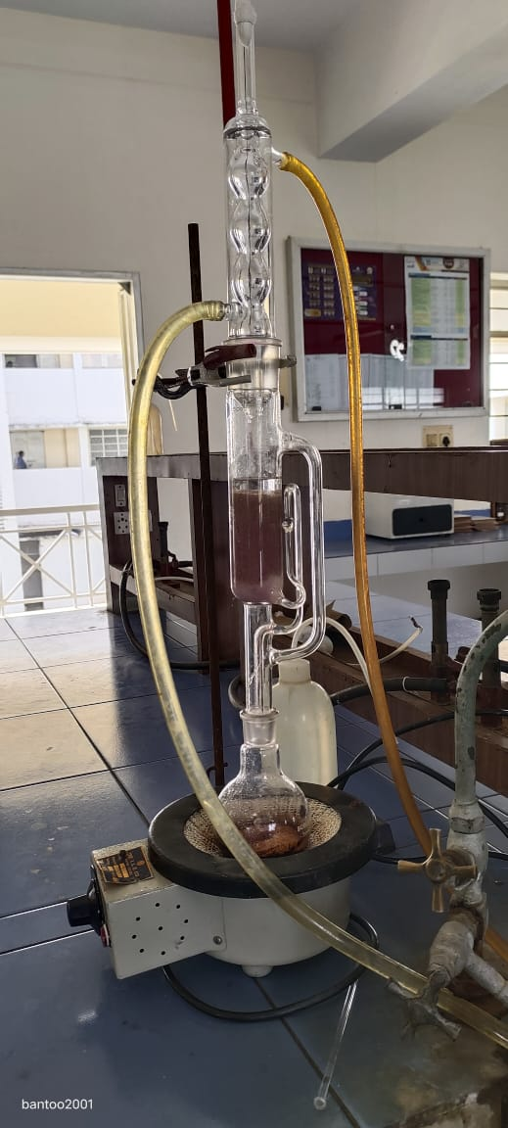 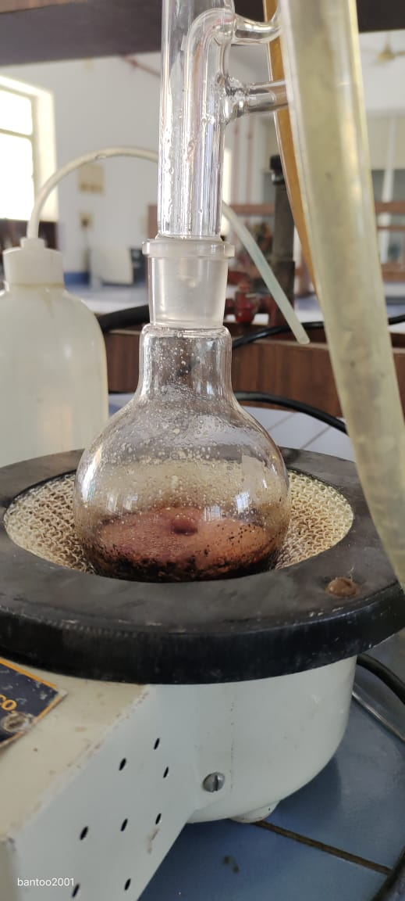

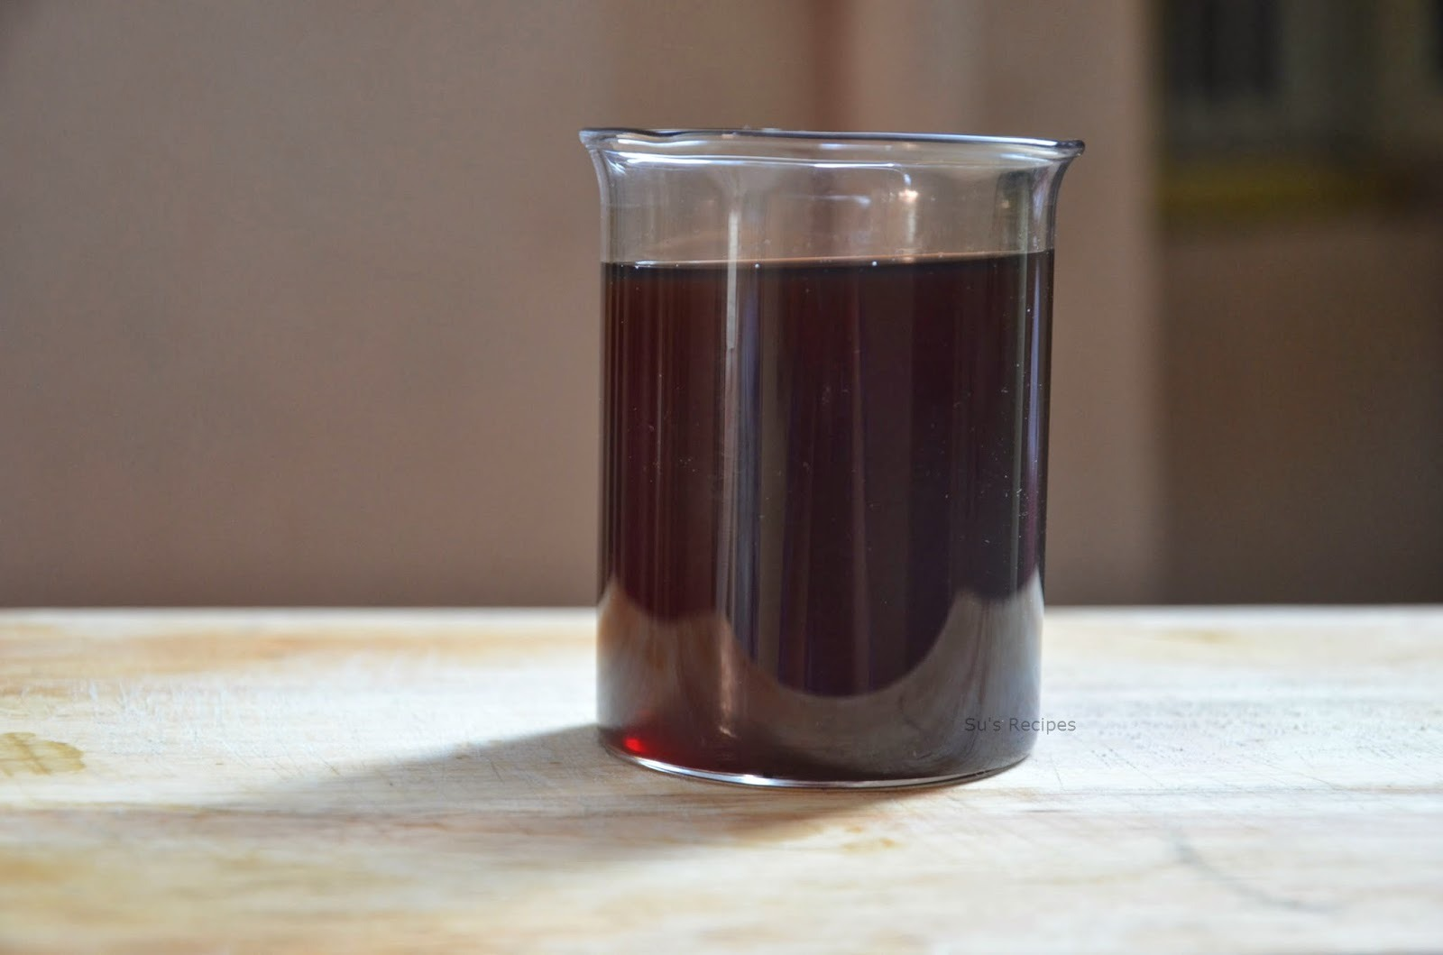

EXTRACT FINAL STAGE

COLUMN CHROMATOGRAPHY

The column was packed with 40-60 mesh gel using n-hexane. The crude sample was mixed with n-hexane and the slurry thus prepared was run in the column Various eluent was used. According the increasing order of their polarity,via benzene,methanol,cholroform There fracts were obtained one in each Benzene, n-hexane,Ethanol .

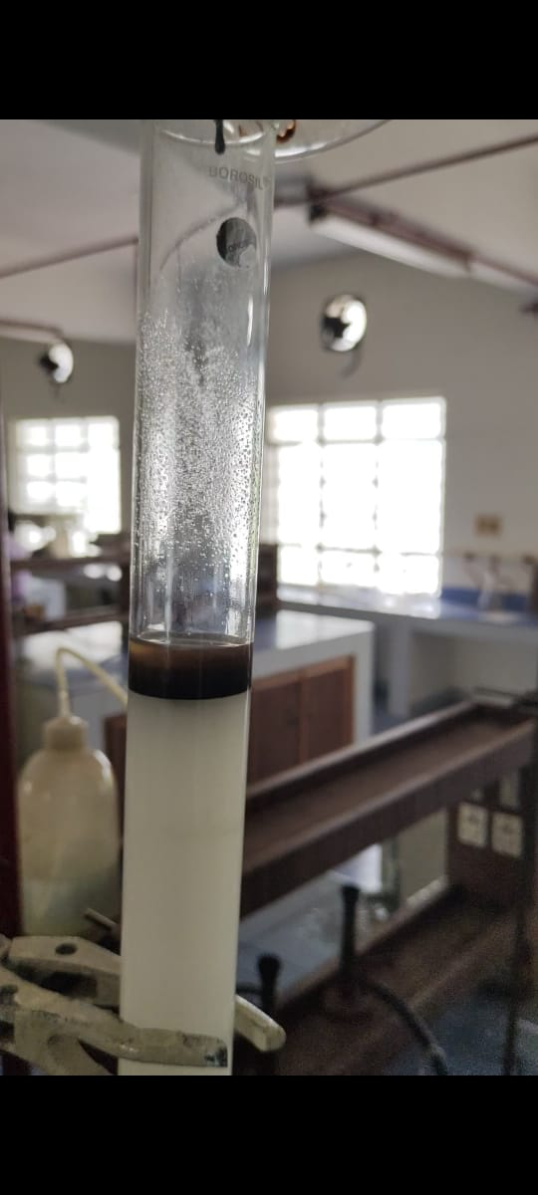 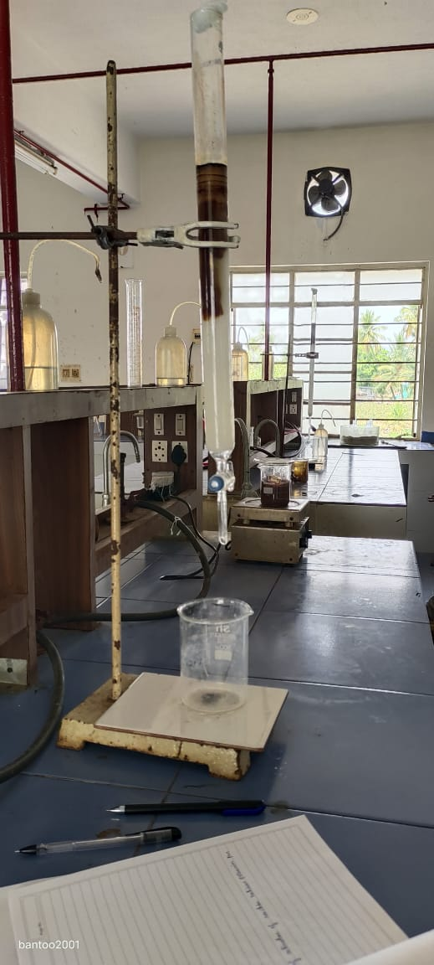

RESULT AND DISCUSSION

The intymicrobial activity of the flower estract was stodiod and it was and to be effective int microbes. The IR-visible spectrum of the flower extret is shown below

IR SPECTRA

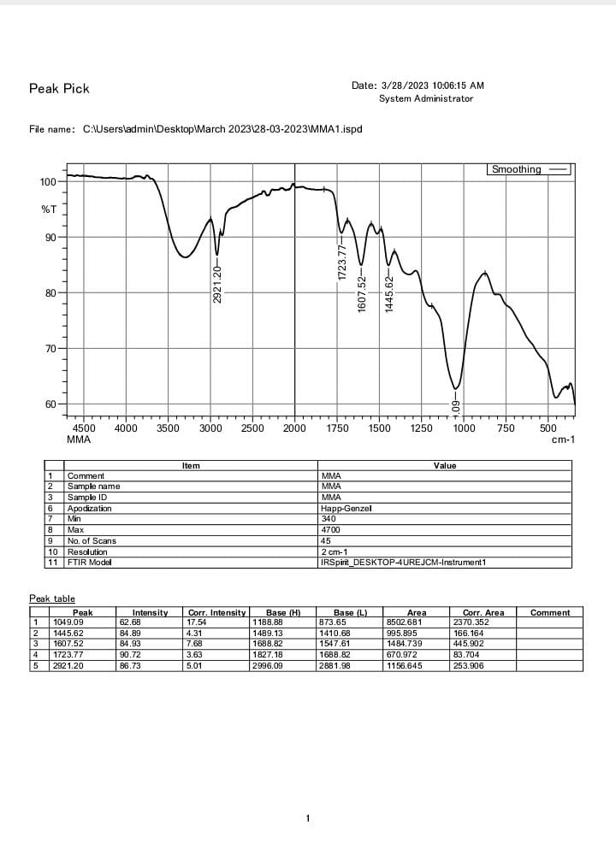

|  |  |  |
| --- | --- | --- |
| PEAK | FROMULA | IR RANGE |
| 2921 | (C-H) | ALKENE |
| 1723.77 | (CHO) | ALDEHYDE |
| 1607 | (C=C) | AROMATIC |
| 1445.62 | (C-H) | ALKANE |

CONCLUSION

The flower extract of Rosa was done using sonhler apparatus The IR spectrum of the were extract showed peaks which indicates the presence of flavonel skeleton. This study will be ether extended for anti-oxidative property of the extract. This will be helpful in designing the echanism for recovery of a person from diseases.